Project Team Charter
ME476C: Capstone I
Signature Cover Page

Each team member will copy the following statement in their own handwriting (LEGIBLY) in one of the designated areas below:

I agree to do an equal amount of work in the team. I understand that my grade will reflect my effort in the team.
Print Name: ___Jacob Keeland ________________ Signature:______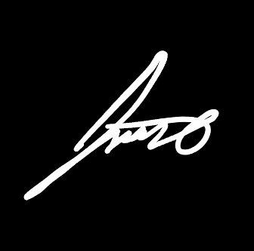________

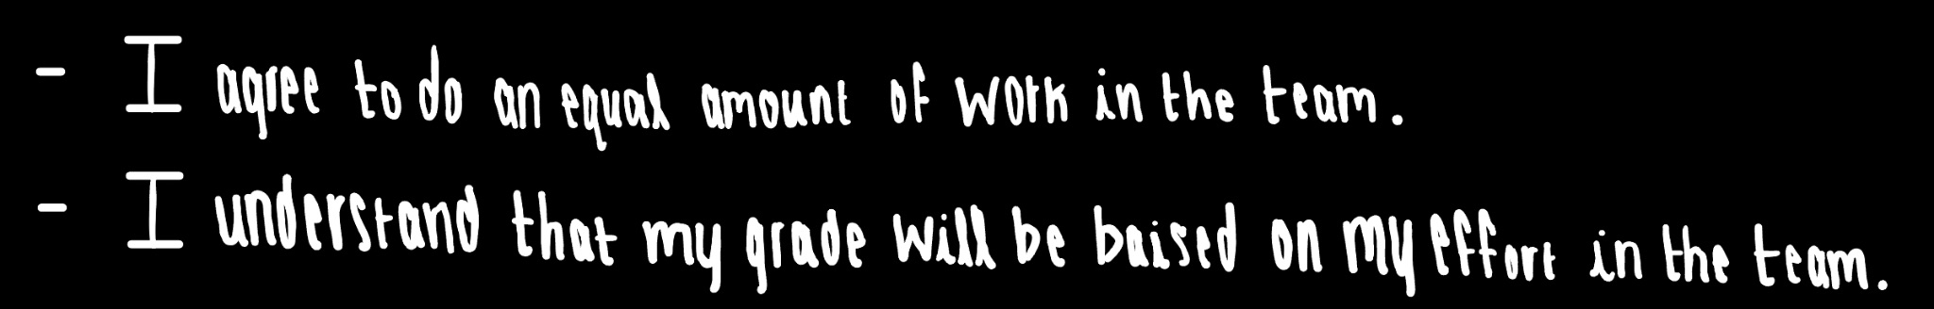

Print Name: ___Selina Cozens_____________ Signature:___

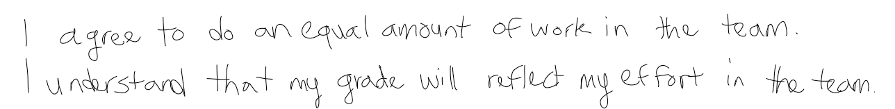

Print Name: ___Natasa Peric_______ Signature: ______

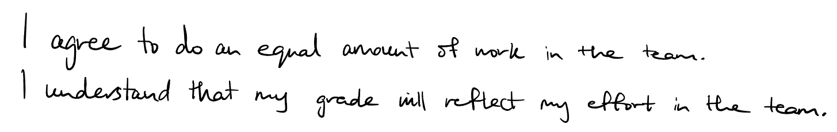

Print Name: _____Desirae Mangum__________ Signature: ___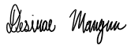____

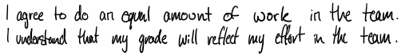

Print Name: _____Marek Lemieux__________ Signature: _______

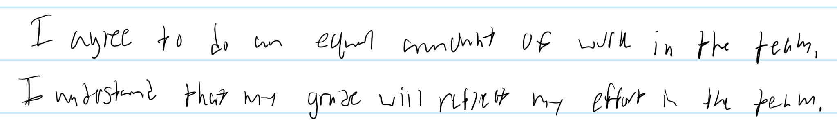

Print Name: _____Elise Chantegros__________ Signature:___ 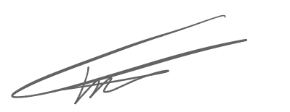___

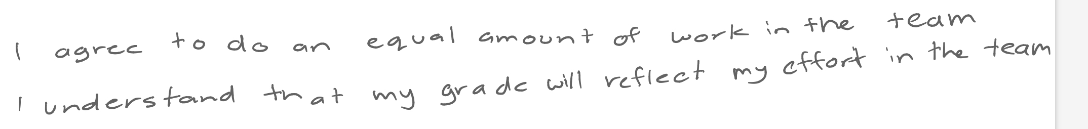

Print Name: _____Dante Palmieri_______ Signature:___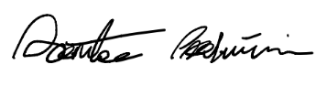______

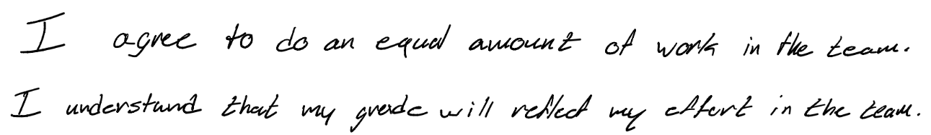

Print Name: ____Seth Jones_____ Signature: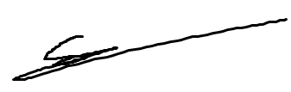

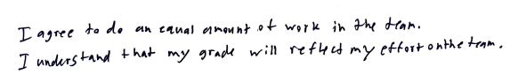

Print Name: _Devon Allan_______________ Signature: 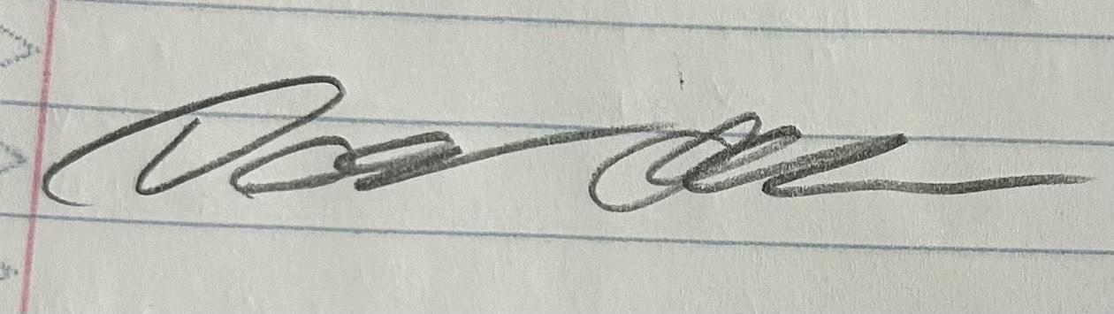
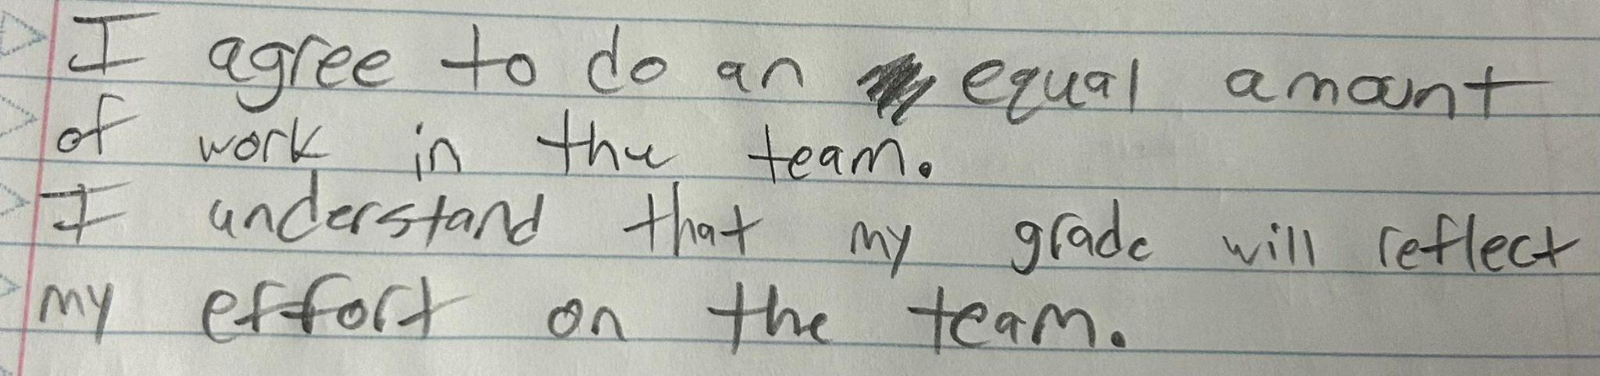

Print Name: ______Evan Hudak___________ Signature:____________________________

Team Purpose

The purpose of this team’s formation is to work collaboratively and effectively to develop an actuation and control system that can be retrofitted onto existing vehicles with traditional controls. Moreover, the team will demonstrate their engineering capabilities and resourcefulness to advertise the project to the clients, Boeing Technical Leads Donald Guzman and Conner Nolan. Their expectations involving safety and quality, trust, client satisfaction, and ownership align with that of which the team expects from themselves.
Our clients, Guzman and Nolan, approached Northern Arizona University to conduct this autonomous driving project. Searching for innovative ideas from the next generation to enter the workforce. Safety, being a key objective of the project at Boeing, prides itself on having the core value of safety as the foundation of everything Boeing does.

Team Goals

For the team’s project goals, we aim to design our project to be adaptable to different automotives. Despite the variety, we expect our project to work efficiently and effectively despite the model. We also aim to put safety first. In order to achieve this, we plan to incorporate fail safe features.
In order to consistently maintain the project’s development, we have set some progress goals for ourselves. We aim to meet at least once a week, work on the project for a minimum of nine hours a week per group member, identify and troubleshoot problems quickly, and fundraise ten percent of the project’s budget before the deadline. In order to keep up with the assignments and their due dates, a Gantt chart will be utilized to keep everyone on the same page. When it comes to effort, measurable in time, a time card will be used for record keeping.
For this project we want to ensure its quality exceeds expectations, so we have a few quality goals. For our goals, we want to accurately document every part of the capstone in order to make sure our documentation is as clear as possible. We want to meet as many expectations academically and industrially for the project. We want to ensure administrative accuracy by utilizing time cards. Each time card will be filled out accurately and submitted before its deadline. Another goal of ours is to minimize malfunction rates and maximize safety metrics. As for our level of commitment for performance, we aim to provide 100% of our effort from each team member unless otherwise stated. Our goal for the final course grade is to achieve an A.

Team Personalities/Roles/Responsibilities

The team divided the responsibilities required for this project into various roles, which can be put into two categories: administrative and technical roles. With each of these, the team discussed who was the best fit based on personality and skills. The distribution of these roles can be seen below, with the team member’s name and role title listed, respectively. Each member is initially assigned one technical responsibility. As the project develops, responsibilities may be expanded or adjusted to ensure a balanced workload and complete coverage of all project requirements.

Administrative Roles:
- Desirae: Fundraising lead
- Selina: Project manager
- Natasa: Computer-Aided Engineering Tool (CAE)
- Elise: Budget liaison
- Jacob: Manufacturing lead
- Marek: Calculation Proofreader
- Seth: Electrical Engineering Lead | Website Manager
- Devon: Electrical Engineering Support

Technical Roles:
- Desirae: Steering Subsystem - Primary Designer
- Selina: Steering Subsystem - CAE tool
- Natasa: Throttle movement - Primary CAD Designer
- Elise: Throttle response - Functions Designer
- Jacob: Brake subsystem - CAE Tool
- Marek: Brake Subsystem - Primary Designer
- Seth: Sensor Subsystem - Primary Designer
- Dante: Processing Subsystem - Primary Designer
- Devon: Wiring - Primary Designer
- Evan: Electrical Engineer

Ground Rules

The team plans to meet both virtually and physically, but will opt for physically whenever possible. After discussing availability, it seems that everybody Tuesdays between 3:35-10pm, Wednesdays 3:35-5:30pm, and Sundays from 8:00am-6:00pm. Our main forms of communication is through a MS Teams group chat, and a mobile group chat. If the discussions and decisions were to take place virtually, we would choose either chat. If we were to meet in person, we would discuss it during a meeting.
If there were to be some dissenting views among members, a discussion including everyone’s opinion would take place until either a decision or middle ground is reached. In order to hold everyone accountable for their tasks and responsibilities, clear and achievable expectations will be established. Proof of effort will be recorded using a time card. Both of the group chats are available to provide support and necessary resources if needed.
It is expected that each team member will complete their assigned tasks before the deadline and will respond to messages labeled “Urgent” within 24 hours. Team members will be responsible for providing progress updates for their team members in order to establish a feedback loop. It is also expected that each team member’s work is done with quality to ensure that project goals and expectations are met. Lastly, one of the most important expectations is that each member will treat each other with respect. Each idea will be listened to and considered.

Individual Availability:
- Elise: Mon, Wed after 2 pm, Tues and Thurs after 10:50, Fri-Sat free all day
- Natasa: Mon and Wed after 3 pm; Sun, Tues, and Thurs free all day
- Marek: Mon, Wed free after 2PM. Tues, Thurs free after 10:50. Sun free all day. Fri and Sat Unavailable.
- Selina: Mon, Wed after 2 pm, Tues, Thurs after 11 am, Weekends all day
- Desirae: Tues-Thurs after 2 pm and Fri-Sat after 5 pm
- Jacob: Mon-Sun: 3:00 pm-8:00 pm
- Seth: Mon and Wed 8:00AM-12:00PM | after 3:30PM. Tues after 11:00AM | Thurs 11:00AM-2:20PM. After 3:30PM | Fri until 2:20PM. After 3:10PM
- Dante: Mon, Wed after 1pm. Tues, Thurs 3:45-5pm. Fri after 3:45pm. Sat, Sun all day.
- Devon: Mon, Wed before 5:30pm, Thurs, Fri, Sun all day

The team will meet on Tuesdays, 5:30-8 pm, in person unless otherwise agreed. All team members are available Tuesdays between 3:35-10pm, Wednesdays 3:35-5:30pm, and Sundays from 8:00am-6:00pm, unless otherwise stated. All team members must respond to messages labelled “URGENT” within 24 hours in the group chat. All team members are expected to check both group chats daily, at least once a day.

Potential Barriers and Coping Strategies

Our team can foresee that this capstone project will have some troubles within most steps of the design, execution, and completion. This is the nature of long term multimembered projects so we have decided to identify potential conflicts now and figure out strategies to avoid slowing progress to our collective goal. We decided to focus mostly on conflicts which are derived from our teamwork since they have the highest likelihood of disrupting the project. These barriers are differing ideas and concepts, time conflicts and constraints, miscommunication, difference in work ethics, and resistance to change. Due to the nature of these barriers we will have to both as a team and on some levels individually adapt to overcome and complete our deliverables.
A major component of our capstone project will be finding creative solutions to complex problems. Things such as measuring the torque needed to turn the steering wheel or force needed for the brakes and throttle have countless solutions but as a team we must decide on only one or two. Since we are all individuals from different backgrounds our ideas for overcoming said tasks will vary wildly. To overcome a gridlock of conflicting ideas we will work together to rank the best ideas using criteria that are important to our cause, one example might be cost since we may need to minimize our spending. This form of meeting in the middle is necessary for overcoming differing work ethics. Since our team is composed of students with other classes and or jobs there is a lot of pressure for some students to work at times they may not be comfortable with. Our solution will be to work on understanding each other's situation and communicate effectively as this can ease tension that could arise from approaching deadlines.
Nine hours a week of work in this project from each member will mean a lot of dedication, loyalty, and perseverance. Friction is bound to arise from this and so we will be working on reaching middle grounds throughout the semester, communicating, and trust in each other. In cases of time conflict we can all agree to a different meeting time/date or members could take notes to share with those not in attendance. Ground rules set such as checking the teams chat at least once a day can help alleviate some of that pressure. All in all we will need to adapt as issues arise and communicate our way through any bumps in the road so we can successfully accomplish our goals.

Project Mentors

The team has reached out to several mentors to help with the project using various expertise and knowledge. At this point in the project, the team has confirmation from Professor Perry Wood at Northern Arizona University to help with certain parts of the design and manufacturing process. Times discussed to meet are anticipated to be biweekly on Fridays at 1pm. Other mentors the team has reached out to are Jimmy Hail from Microtronics and Parker Manor from J.M. Smucker. The team also plans to discuss any possible mentors or companies that can offer mentoring support suggested by Boeing manufacturing leads Donald Guzman and Conner Nolan.
GROUND RULES FOR DIFFICULT GROUP DISCUSSIONS
Ideally, group discussions should be calm, focused conversations in which various ideas and opinions are considered, leading to useful, productive outcomes. But in the real world, many groups just can’t pull this off. When members have conflicting interests, personal agendas, or aggressive personalities, meetings often deteriorate into angry conflicts, thereby wasting time and harming relationships.

If you anticipate that your group could head down this destructive path, try to get agreement on how the discussion will be conducted before leaping right into the issues. Unless they just enjoy anger and hostility, group members will usually agree to a reasonable set of Ground Rules. Then, if things start to get out of hand, the leader or facilitator can simply remind the wayward members of their previous agreement.

Although each group may have specific needs, the Ground Rules listed below are often useful. (These can apply to personal conversations as well.)
- Stay focused on the purpose and goals. The group should clearly define what they hope to accomplish at the beginning of a discussion. This makes it easier to determine when people are getting off track.
- Listen when others are speaking. During difficult discussions, people often mentally rehearse their next comment while someone else is talking, with the result that no one is really listening. When this happens, the conversation tends to turn into a pointless debate.
- Be sure that all viewpoints are heard. Since most groups have both talkative and quiet members, efforts should be made to invite the quiet people to share their thoughts and keep the talkers from dominating the discussion.
- Consider different points of view. People easily get “locked in” to their own opinions and don’t even think about the possible merits of other ideas. Members need to be encouraged to think beyond their own point of view.
- Look for areas of agreement. Argumentative group members often agree on more things than they realize. Before discussing disagreements, members should identify the things they do agree on.
- Discuss differences respectfully. Hostile, insulting remarks add nothing to a group discussion and often permanently damage relationships. Members should be reminded about basic “good manners” for meetings.
- Remember that facts can be wrong, but opinions are just different. Most of the time, people are not arguing about facts, but expressing differences of opinion. However, they often act as though their views are “right” and others are “wrong”. It helps to recognize that they are simply different.
- Look for the good points in new ideas. Useful ideas may get rejected when people are too quick to find flaws. By initially exploring the benefits of an idea, the group can avoid becoming overly critical.
- Focus on the future, not the past. Disagreements can easily deteriorate into finger‐pointing about past mistakes and problems, which accomplishes absolutely nothing. Use past experience to inform your decisions, but focus the discussion on future goals.
- Look for solutions, not someone to blame. The worst debates about the past are those which involve placing blame. Any conversation focused on blaming is unproductive and should be turned into a search for solutions.
- Don’t use group time for individual issues. When two or three members start discussing their own issues in a group meeting, it just wastes everyone else’s time. If this happens, the people involved should be politely asked to continue their personal discussion after the meeting.
- “Sidebar” any issues that are important but off--‐topic. Occasionally, important matters are raised that have nothing to do with the goals of the meeting. To keep the group on task, but avoid losing the issue, create a “sidebar” where these topics can be listed and dealt with later.
- Agree upon specific action steps. In most situations, members need to end the discussion with specific “next steps” that can be acted on after the meeting. Otherwise, the whole thing may turn out to be a waste of time.

Copyright Marie G. McIntyre. All rights reserved. May be reproduced with copyright and attribution to www.yourofficecoach.com.

